**Lab 3**

Cascode Amplifier

Part 1: Sizing Chart

Required Spec:

|  |  |
| --- | --- |
| **L** | 0.5um |
| **V\*** | 160mV |
| **Supply** | 3v |
| **Current Consumption** | 10uA |

Analytic Calculations:

$$\left|A_{v}\right|≈g_{m}ro=\frac{2I_{D}}{V_{ov}}×\frac{V_{A}}{I_{D}}=\frac{2V_{A}}{V_{ov}}$$

$$In Simulation V_{ov}≠\frac{2I_{D}}{gm} all the time, Instead use V^{*}=\frac{2I_{D}}{gm}$$

$$\left|A_{v}\right|=\frac{2V_{A}}{V^{*}}$$

All we need to calculate now is W, which we will do using sizing charts.

Testbench Schematic**:**

Using **W/L = 10u/0.5u** and **VDS = 1.5 V** NMOS only since we aren’t using PMOS in this Lab

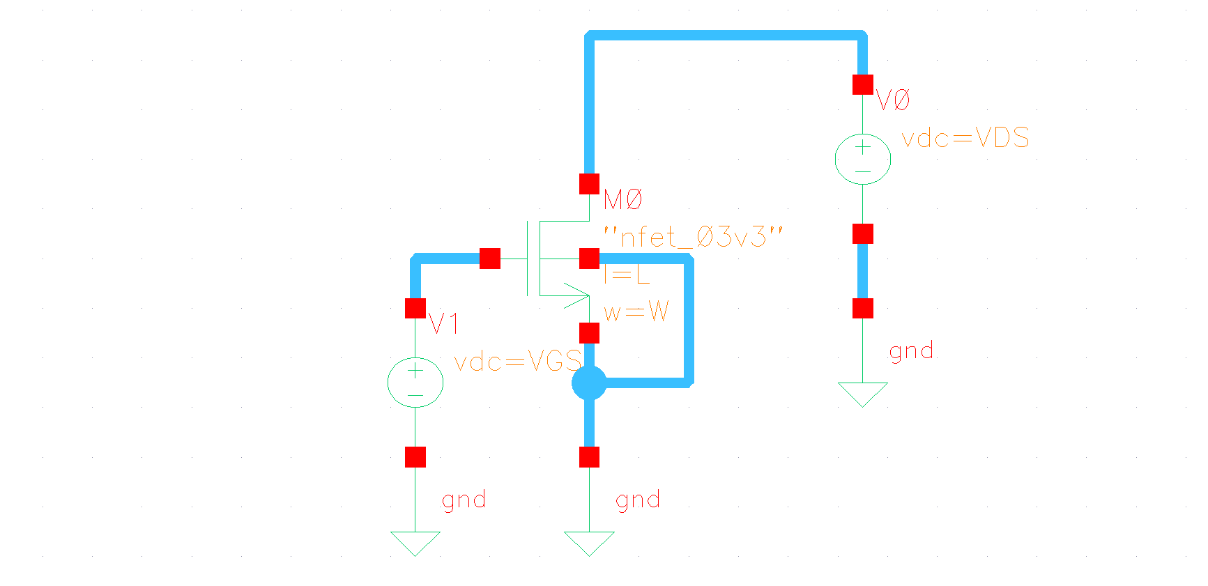

Figure Sizing Testbench Schematic

Sweeping VGS from 0:10mV:(Vth + 0.4):

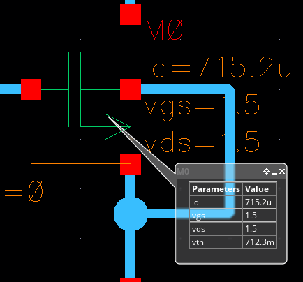I ran a simple DC Op once to determine the value of VTH

$$V_{th}=712.3m$$

$$Sweep Range →0:10mV:1.1123V$$

Figure Value of Vth from simulation

V* and Vov Overlaid vs VGS:



Figure Output Setup and Expressions for Vov and V*

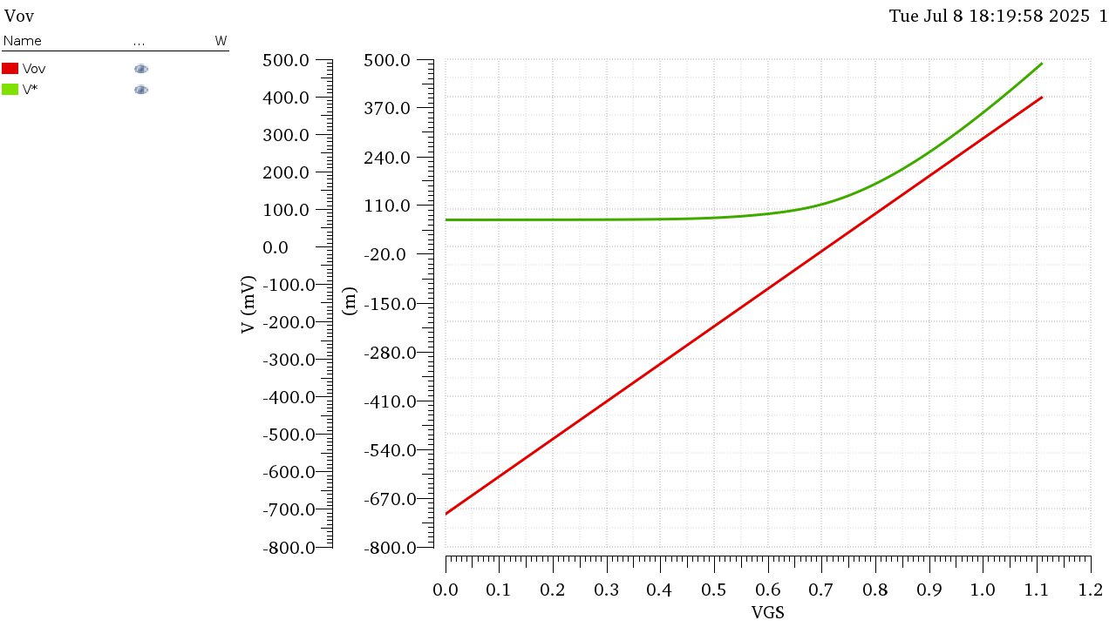

Figure Vov and V* vs VGS NMOS

**Comment:** Vov and V* are relatively close in value to each other at the region of moderate inversion meaning the square law is relatively valid there . But for Deep Strong inversion (Large Vov) or weak inversion, the behavior is quite far from the square law.

Locating V*Q and VGSQ, Vovq:

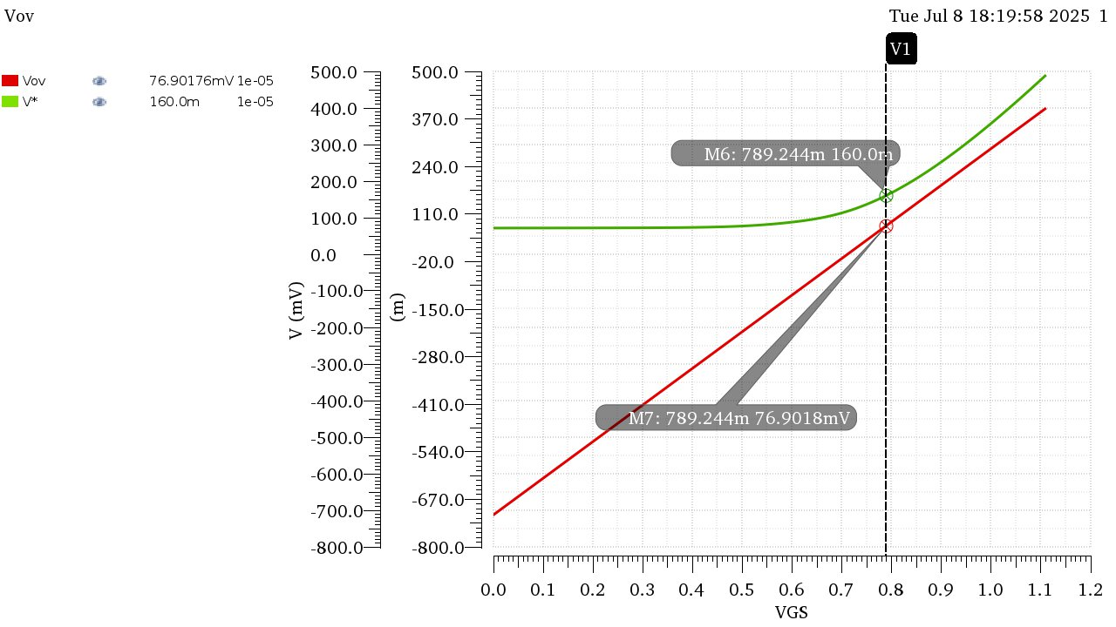

Figure V*q, Vovq and Vgsq NMOS

$$@V_{Q}^{*}=160mV, V_{ovQ}=76.902mV, V_{GSQ}=789.244mV$$

Plotting ID, gm, gds vs VGS:

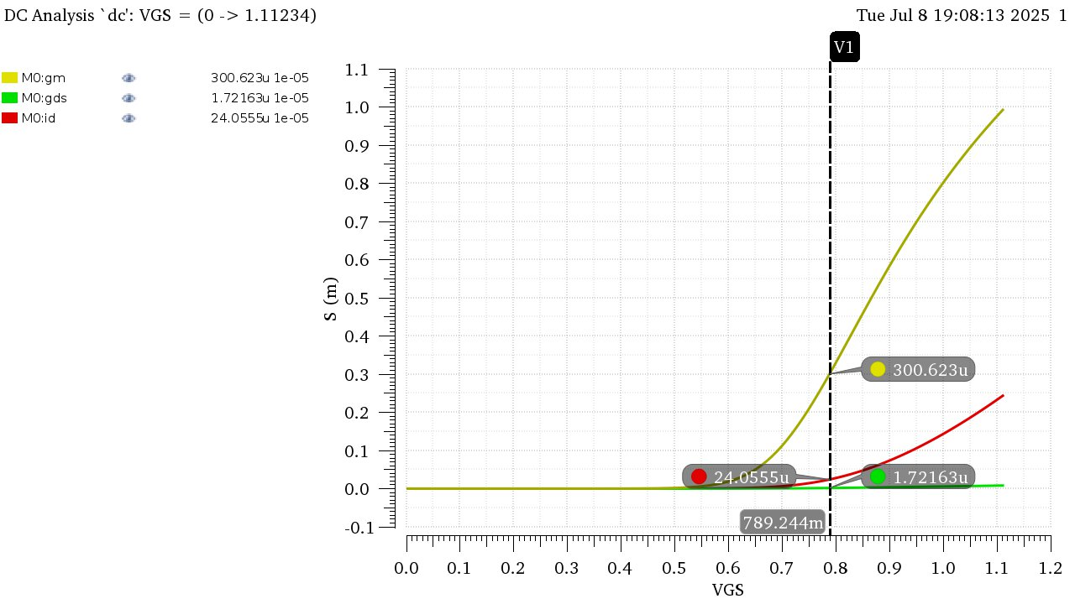

Figure ID, gm, gds vs VGS and their corresponding values at Vgsq

|  |  |
| --- | --- |
| **IDx** | 24.0555 uA |
| **gmx** | 300.523 uS |
| **gdsx** | 1.72163 uS |

Getting the Value of W:

These Values were Calculated at W = 10um, to get the actual value of W for the design we can simply do cross multiplication since Id is directly proportional to W regardless square law is valid or no.

|  |  |
| --- | --- |
| 𝑾 | 𝑰𝑫 |
| 𝟏𝟎𝝁𝒎 | 𝐼𝐷𝑋 @𝑉𝑄∗ (from the chart) |
| **?** | 𝐼𝐷𝑄 = 10𝜇𝐴 (from the specs) |

$$W=W*\frac{I_{DQ}}{I_{DX}}= \frac{10μ*10μ}{24.0555μ}=4.157μm$$

Calculating the remaining Design parameters:

Using cross-multiplication we can get the values of gmQ and gdsQ as follows…

|  |  |  |
| --- | --- | --- |
| **W** | **gm** | **gds** |
| 𝟏𝟎𝝁𝒎 | gmX = 300.523 uS | gdsX = 1.72163 uS |
| $4.157$ 𝝁𝒎 | gmQ | gdsQ |

$$gm_{Q}=\frac{4.157μ*300.523μ}{10μ}≈124.93 uS , gds_{Q}=\frac{4.157μ*1.72163μ}{10μ}=0.7157μS$$

$$ro=\frac{1}{gds}=\frac{1}{0.7157μs}=1.397MΩ$$

Final Parameter List:

|  |  |
| --- | --- |
| **Supply** | 3 V |
| **V\*** | 160 mV |
| **ID** | 10 uA |
| **W** | 4.157 um |
| **L** | 0.5 um |
| **gm** | 124.93 mS |
| **gds** | 0.7157 uS |
| **ro** | 1.397 MΩ |
| **Vgs** | 789.244 mV |

Part 2: Cascode for Gain

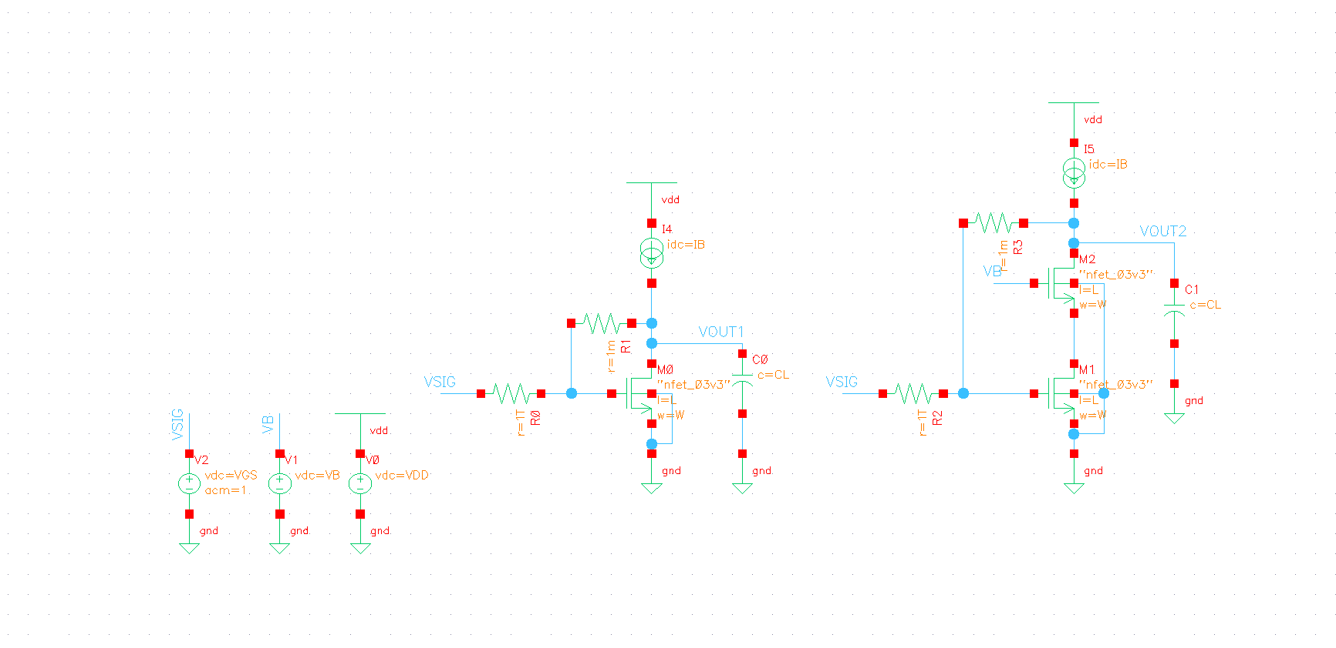

Figure CS Amplifier and Cascode Amplifier

Finding VB:

Vds of should be $V_{DS}≈V^{*}+100mV≈260mV$

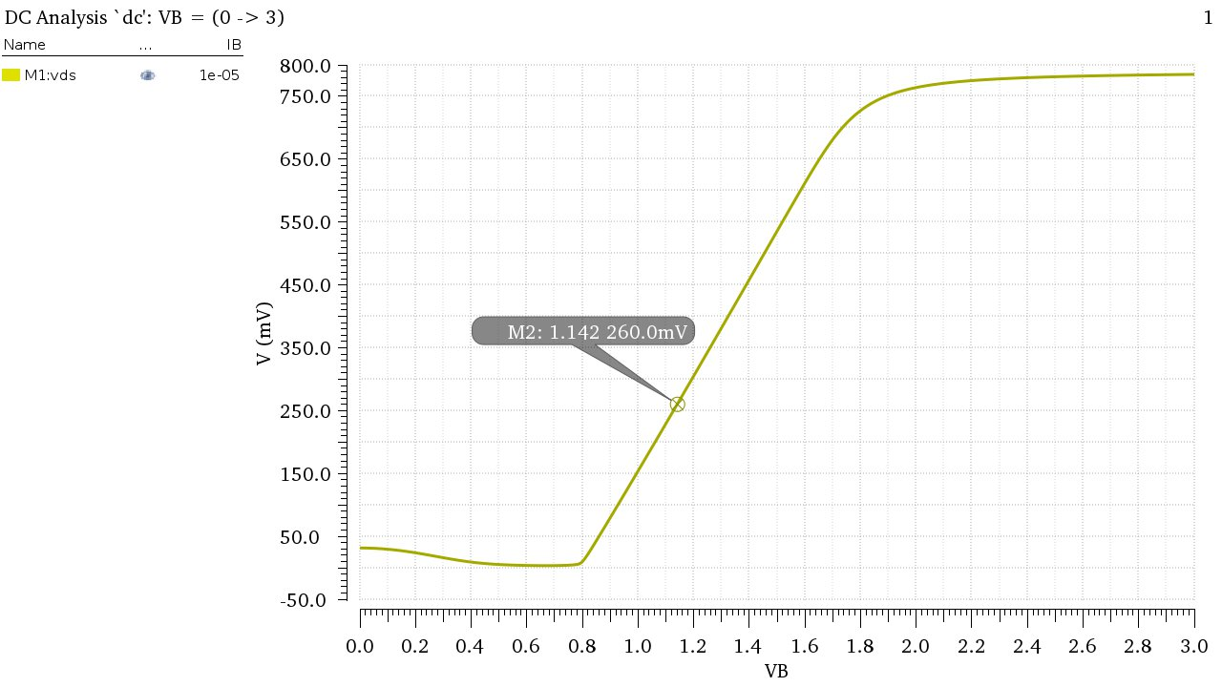

Figure VDS of M1 vs VB

Ideal value of VB = **1.142V**

DC Operating Point:

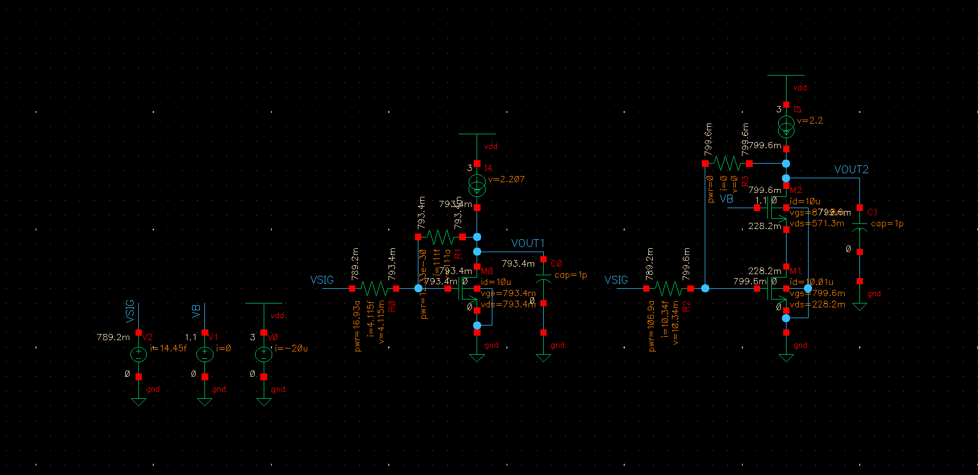

Figure DC Voltages Annotated on Schematic

The following table holds the required DC Operating Point parameters for each transistor where: M0 is the CS Amplifier, M1 is Cascode Bottom Transistor, M2 Cascode Top Transistor.

|  |  |  |  |
| --- | --- | --- | --- |
|  | M0 | M1 | M2 |
| ID | 10.0 uA | 10.0 uA | 10.01 uA |
| VGS | 793.4 mV | 798.8 mV | 881.6 mV |
| VDS | 793.4 mV | 258.4 mV | 540.3 mV |
| VTH | 710.1 mV | 710.8 mV | 795.4 mV |
| VDSAT | 135 mV | 138.1 mV | 138.6 mV |
| gm | 124.8 uS | 122.3 uS | 124.2 uS |
| gds | 886.7 nS | 2.61 uS | 1.09 uS |
| gmb | 44.68 uS | 43.81 uS | 38.68 uS |
| Cdb | 544.6 aF | 565.3 aF | 477.9 aF |
| Cgd | 776.7 aF | 847.1 aF | 823.9 aF |
| Cgs | 4.33 fF | 4.42 fF | 4.4 fF |
| Csb | 815.8 aF | 834.1 aF | 714.8 aF |
| Region | 2 | 2 | 2 |

* Check that all transistors operate in saturation.

They all operate in saturation.

* Do all transistors have the same vth? Why?

M0 and M1 have the same VTH as they have the same VSB, but M2 has a higher VTH due to the higher voltage seen at its source.

* What is the relation (≪, <, =, >, ≫) between gm and gds?

gm >> (Much Greater Than) gds

* What is the relation (≪, <, =, >, ≫) between gm and gmb?

gm > (Greater Than) gmb

* What is the relation (≪, <, =, >, ≫) between cgs and cgd?

Cgs >> (Much Greater Than) Cgd

* What is the relation (≪, <, =, >, ≫) between csb and cdb?

Csb > (Greater Than) cdb

AC Analysis:

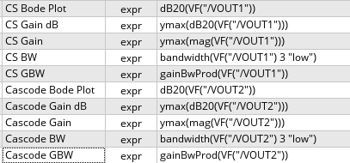

Figure AC Output Setup

**Outputs:** 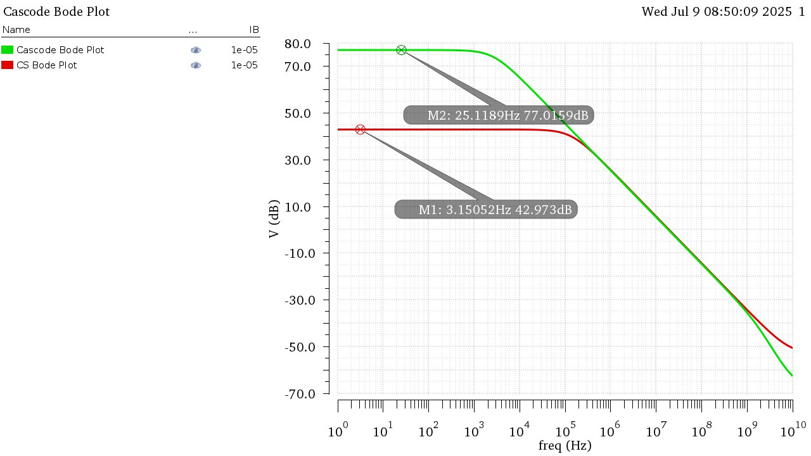

Figure Bode Plots of both CS and Cascode Amplifiers

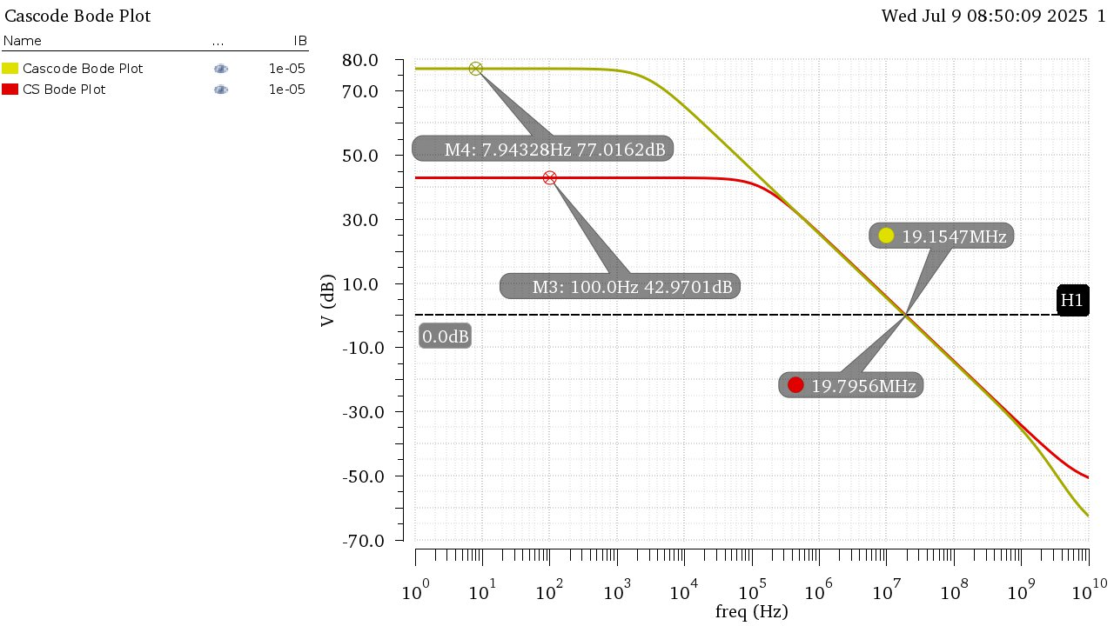

Figure Gain and UGF Highlighted on Bode Plot

|  |  |  |
| --- | --- | --- |
|  | CS | Cascode |
| Gain (dB) | 42.97 | 77.02 |
| Gain | 140.8 | 7.09 K |
| BW | 140.6 KHz | 2.69 KHz |
| GBW | 19.84 MHz | 19.14 MHz |
| UGF | 19.7956 MHz | 19.1547 MHz |

All Results:

Hand Analysis:

CS Amplifier:

$$DC Gain=|A_{v}|=gm*ro=\frac{gm}{gds}=\frac{124.8μ}{886.7n}≈140.75$$

$$Gain in dB=20Log\left(A_{v}\right)=20Log\left(140.75\right)=42.97dB$$

$$Bandwidth \left(Neglecting Parasitic Capacitances and current source resistance\right):$$

$$F_{P}=\frac{1}{τ*2π}=\frac{1}{2π*ro*C_{L}}=\frac{gds}{{2π*C}_{L}}=\frac{886.7n}{2π*1p}=141.122 KHz$$

$$GBW=Gain*BW=140.75*141.122K=19.863MHz$$

$$Since this is a Single Pole System: UGF=GBW=19.863MHz$$

Cascode Amplifier:

$$R_{out}≈ro_{2}\left(gm_{2}+gmb_{2}\right)ro_{1}=\frac{gm_{2}+gmb_{2}}{gds_{1}*gds_{2}}=\frac{124.2μ+38.68μ}{2.61μ*1.09μ}=57.253MΩ$$

$$DC Gain=|A_{v}|=Gm*R_{out}=gm_{1}*R_{out}=122.3μ*57.253M≈7K$$

$$Gain in dB=20Log\left(A_{v}\right)=20Log\left(7K\right)=76.9 dB$$

$$Bandwidth \left(Neglecting Parasitic Capacitances and current source resistance\right):$$

$$F_{P}=\frac{1}{τ*2π}=\frac{1}{2π*R_{out}*C_{L}}=\frac{1}{2π*1p*57.253M}=2.78 KHz$$

$$GBW=Gain*BW=7K*2.78K=19.46 MHz$$

$$Since this is a Single Pole System: UGF=GBW=19.46MHz$$

Comparison of Results:

|  |  |  |  |  |
| --- | --- | --- | --- | --- |
|  | **CS** | | **Cascode** | |
|  | Simulation | Analytic | Simulation | Analytic |
| **Gain (dB)** | 42.97 | 42.97 | 77.02 | 76.9 |
| **Gain** | 140.8 | 140.75 | 7.09 K | 7 K |
| **BW** | 140.6 KHz | 141.122 KHz | 2.69 KHz | 2.78 KHz |
| **GBW** | 19.84 MHz | 19.863 MHz | 19.14 MHz | 19.46 MHz |
| **UGF** | 19.7956 MHz | 19.863 MHz | 19.1547 MHz | 19.46 MHz |

Comments:

* Simulation and Analytic Results are nearly identical!
* Cascode amplifier has a much greater gain than the CS Amplifier. Due to the higher output resistance
* The Bandwidth of the Cascode Amplifier is much lesser than the CS Amplifier also due to the higher output resistance.
* This results in both amplifiers having nearly identical Gain-Bandwidth-Product as well as Unity Gain Frequency.